

SIMPLER Consortium in collaboration with the Chamber of commerce of Versailles, the Regional Chamber of commerce of Bretagne, of Midì-Pyreneé and Provence organizes bilateral meetings between Italian and French companies in the framework of International Fair COSMOPROF in Bologna on **16th of April.**

COSMOPROF, world’s most important international event in the beauty and cosmetics sector, now also with a special focus on the Spa industry, gathers each year over 2.000 exhibitors (more than 50% international) and approximately 140.000 visitors.

As partner of the “[**Enterprise Europe Network**](http://www.enterprise-europe-network.ec.europa.eu/index_en.htm)”, SIMPLER Consortium, covering Lombardy and Emilia-Romagna, has collaborated with the Chamber of commerce of Versailles, the Regional Chamber of commerce of Bretagne, of Midì-Pyreneé and Provence in order to select foreign companies.

The event is aimed at manufacturers and suppliers of cosmetics, producers and designers of machinery for the cosmetic sector.

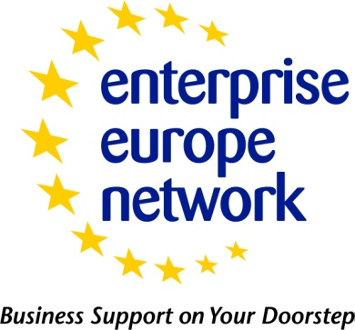**Enterprise Europe Network** is a part of the EU’s Competitiveness and Innovation Framework (CIP) and it offers support and advice to businesses across Europe and helps them make the most of the opportunities in the European Union. The services are specifically designed for small and medium enterprises (SMEs) but are also available to all businesses, research centres and Universities across Europe. The Enterprise Europe Network is made up of close to 600 partner organizations in more than 40 countries, promoting competitiveness and innovation at the local level in Europe and beyond.  
**Find out more**: <http://www.enterprise-europe-network.ec.europa.eu>

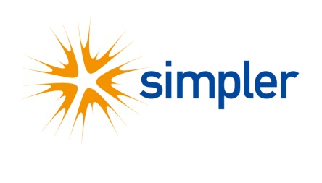In the framework of Enterprise Europe Network, **SIMPLER** - Support Services to IMProve innovation and competitiveness of businesses in Lombardia and Emilia-Romagna - is the interregional consortium that offers support and advice to the SME of Emilia-Romagna and Lombardy region . The partners of Simpler are: Unioncamere Emilia-Romagna, the Chamber of commerce of Ravenna - Azienda speciale Eurosportello, Alintec, Cestec spa, the Chamber of commerce of Milan, Fast and Aster.  
**Find out more**: <http://www.simplernet.it>