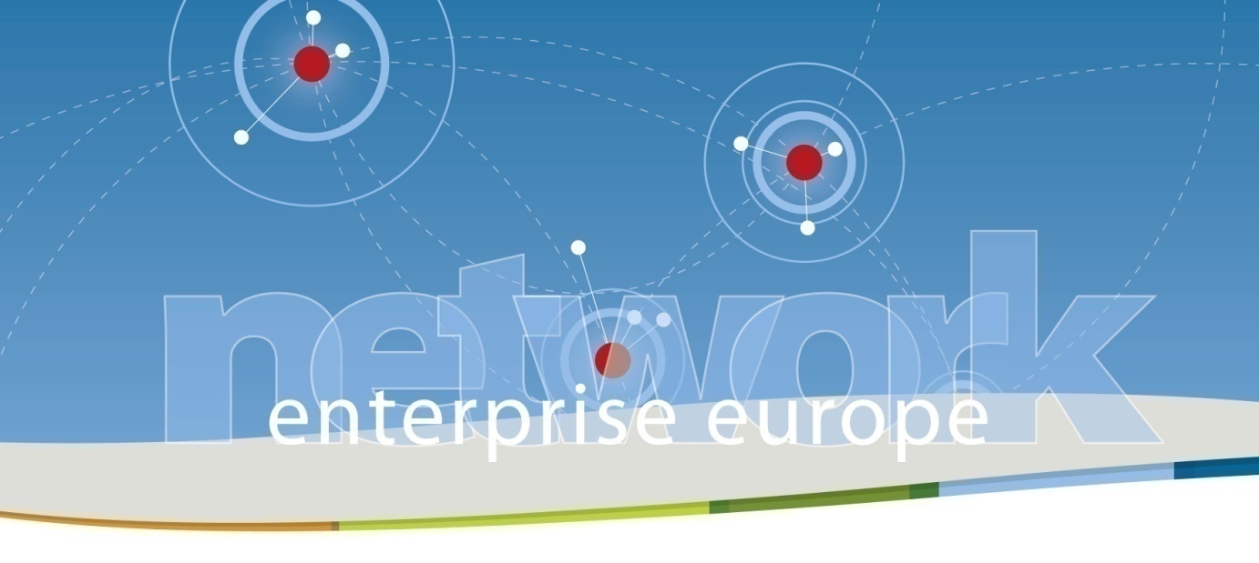

**Company mission in the packaging sector**

**Milan, March 1-2 2012**

On the occasion of IpackIma 2012, the SIMPLER consortium organizes a company mission in the field of packaging. The fair is one of the most important international events in the industry of packaging, processing and material handling technology,boasting 1,400 exhibitors and 54,000 visitors in the previous edition held in 2009. The fair covers all the issues and topics related to the sector of packaging, from packaging and processing machinery to package printing and manufacturing, from liquid filling machinery and beverage technologies to confectionary, from material handling and logistics to labeltrack and traceability.

For more information on the fair: <http://www.ipack-ima.it/eng/home>

The company mission will take place on March 1-2 at Milan Exhibition Fair with the following provisional schedule:

**March1:**

Morning : Companies short presentations (5’)

Afternoon. Prearranged bilateral meetings

**March 2**: Free visit of the fair

**Deadline for registration**: February 18, 2012

**Location:**Camera di Commercio di Milano Fair branch - RHO FIERA

Porta Est, Ponte dei Mari Est E/19, First floor

**Costs :**Participation is free of charge!

|  |  |  |
| --- | --- | --- |
| Logo-NET-EN | Immagine.jpg | DGENTR-signature-EN-black |

Companies and research centers active in the sector packaging are welcome!

For further information: [angela.pulvirenti@fast.mi.it](mailto:angela.pulvirenti@fast.mi.it) +39-0277790309