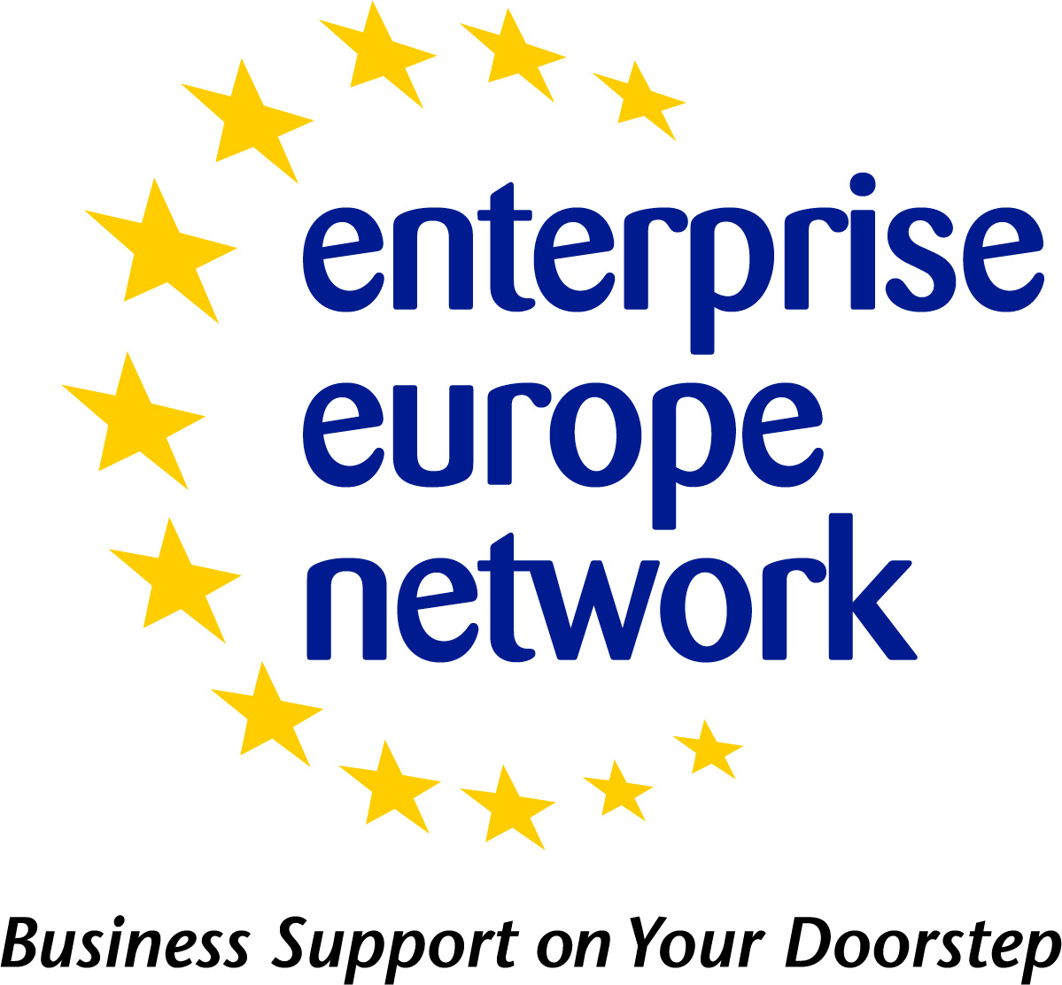 | Business Offer - Profile Template
 |  | 
Company Profile – Contact Details

(All fields are mandatory - The fields in grey are confidential and for internal use only)
Company: |  | City: |  |  | Country:
Street: |  |  |  |  | Postal Code:
www-Address: |  | Contact person:
Position in the company: |  | Telephone: |  |  | Fax
General e-mail address: |  |  | E-mail contact person:

Business Offer Profile
Please note:
- Fields marked with asterisk (*) are mandatory
Field Title | Field To be populated
Title*
Summary
(1-500 characters)
Advantages and Innovations*
(50-2000 characters)
Stage of Development | Already on the market  Available for demonstration  Concept Stage  Field Tested / Evaluated  Project Already Started  Project in Negotiations - Urgent  Proposal under development  Prototype available for demonstration  Under development / lab tested
Comments Regarding Stage of Development
Description *
(100-4000 characters)
Technical Specification or Expertise Sought
IPR Status  Note: Multiple fields can be selected. | Copyright  Design Rights  Exclusive Rights  Granted patent or patent application essential  Other (registered design, plant variety, etc.)  Patent(s) applied for but not yet granted  Patents granted  Secret Know-how  Trade Marks
Comments Regarding IPR Status
Target countries | Please take a look at: http://een.ec.europa.eu/about/branches
Type and Size of Client* | Industry SME <= 10  Industry SME 11-49  Industry SME 50 – 249  Industry 250-499  Industry >500  Industry MNE >500  Inventor  Other  R&D institution  University
Year Established*
Turnover *  (Euros – Millions) | <1M  1-10M  10-20M  20-50M  50-100M  100-250M  250-500M  >500M
Already Engaged in Trans - national Cooperation? | Yes  No
Additional Comments
Certification Standards
Language Spoken*
Client Country
Type and Role of Partner Sought*
Type and Size of Partner Sought  Note: Multiple fields can be selected. | SME < 10  SME 11-50  SME 51 – 250  251-500  >500  MNE >500  Inventor  R&D institution  University
Type of Partnership Considered*  Note: Multiple fields can be selected. | Acquisition Agreement  Commercial Agency Agreement  Distribution Services Agreement  Financial Agreement  Franchise Agency Agreement  Joint Venture Agreement  License Agreement  Manufacturing Agreement  Outsourcing Agreement  Reciprocal production  Services Agreement  Subcontracting
Attachments | *Only can be added in Merlin*  File Size max 4Mb. Only jpg, gif and jpeg files allowed.

Date Signature
____________________ ____________________

